Calculus 2 Lecture 9.7: Power Series, Calculus of Power Series, Ratio Test for Interval of Convergence

Power series: A series with a variable “x” that is being raised to some power, “n”
1. 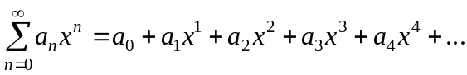
A power series in “x” centered at the origin

A power series in “x” centered at “c”

Example
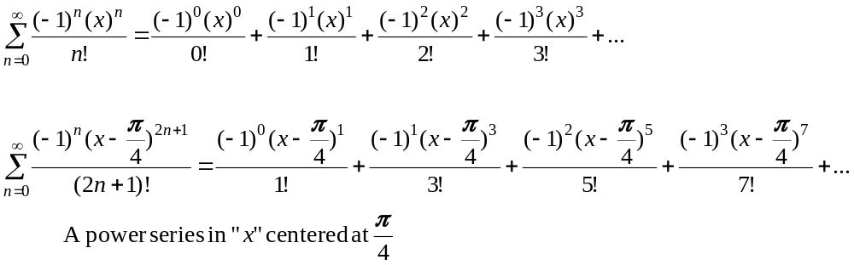

Power series creates a function of “x”

When a value of x is plugged into the function the series 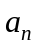 either converges of diverges

Example
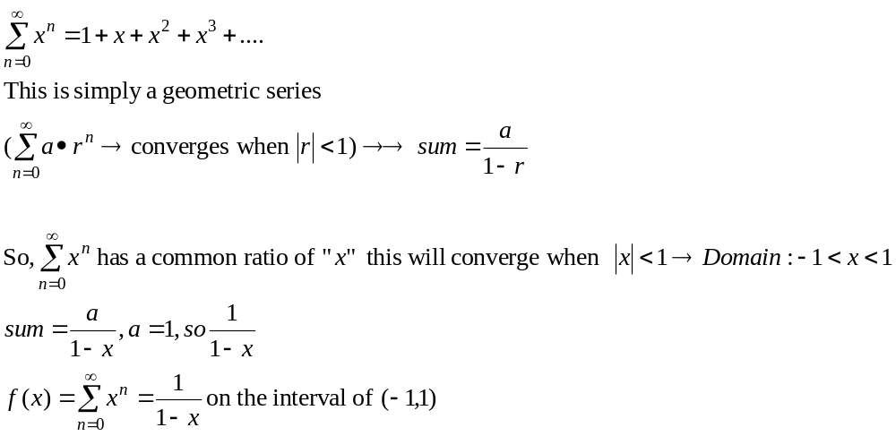
For the general power series
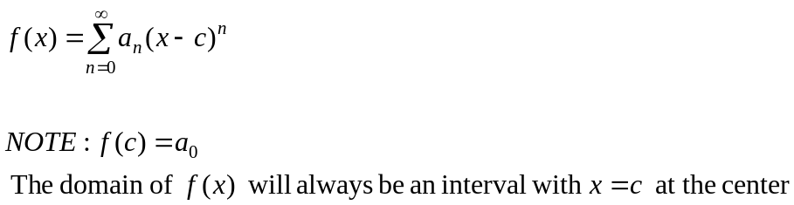

Convergence of a power series could be
R is the Radius of convergence
- 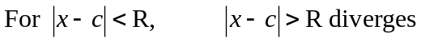
To discover if the endpoints are included in the interval do a convergence test.

Example
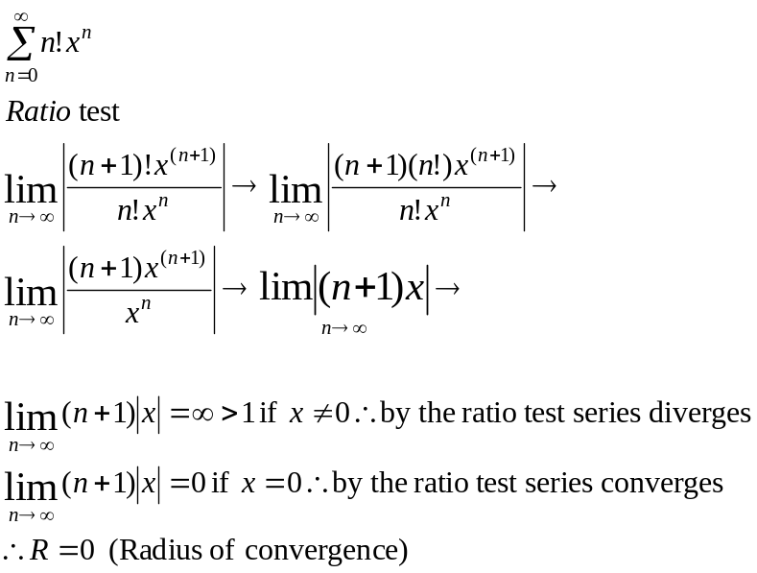

Example
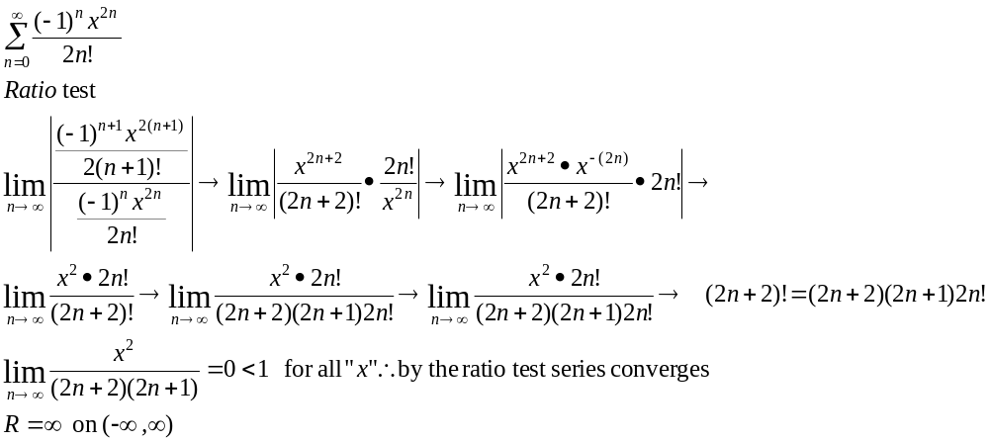

Example
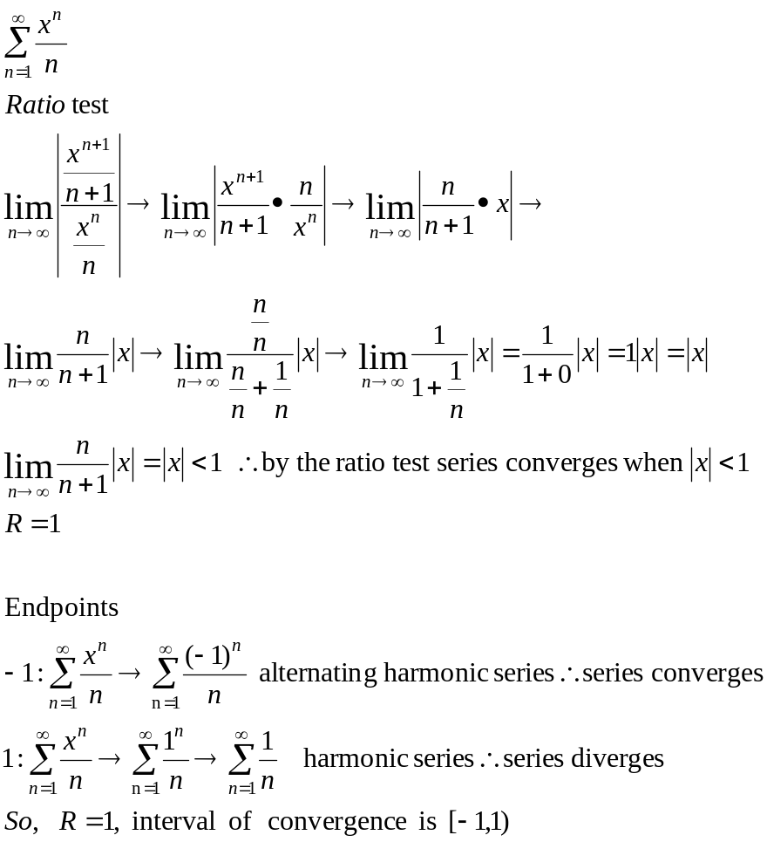

Example
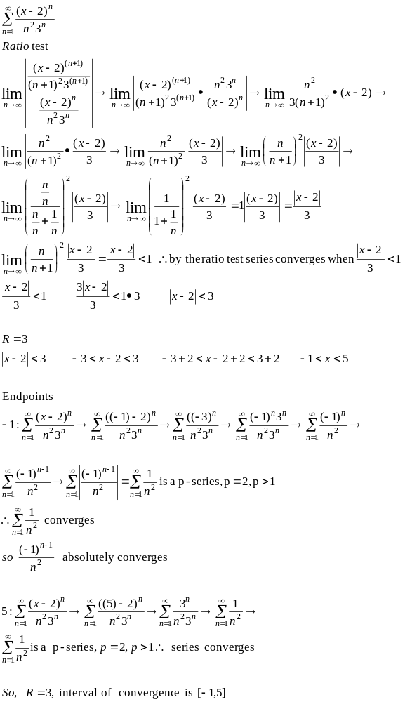
Example
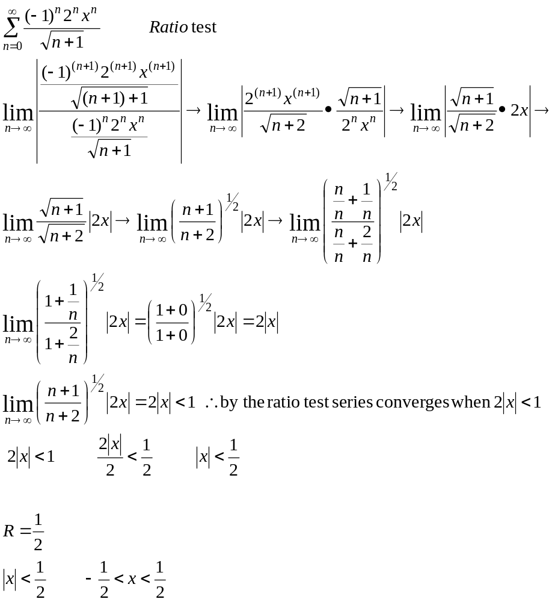
Derivatives and Integrals of Power series
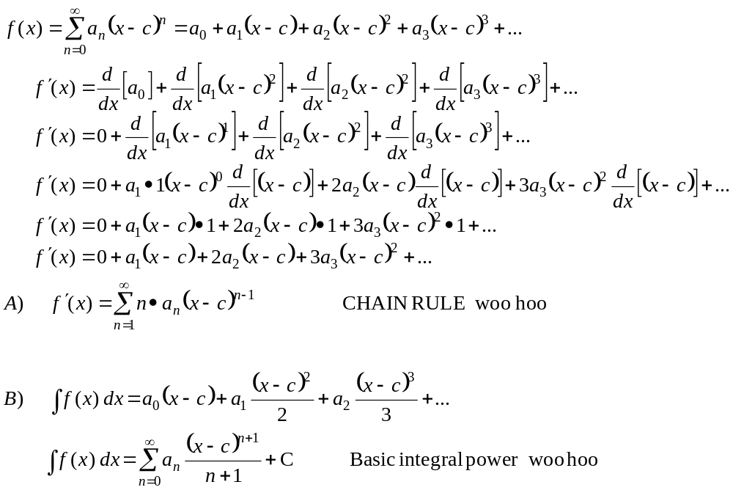

Example:
Find a power series representation of 